**AI ASSESTED COADING**

**ASSIGNMENT-5.3**

**Task Description#1 (Privacy and Data Security)**

* Generate a login system using an AI tool. Analyze if the AI inserts hardcoded credentials or insecure logic.

**Expected Output#1**

* Description of risks and revised secure version

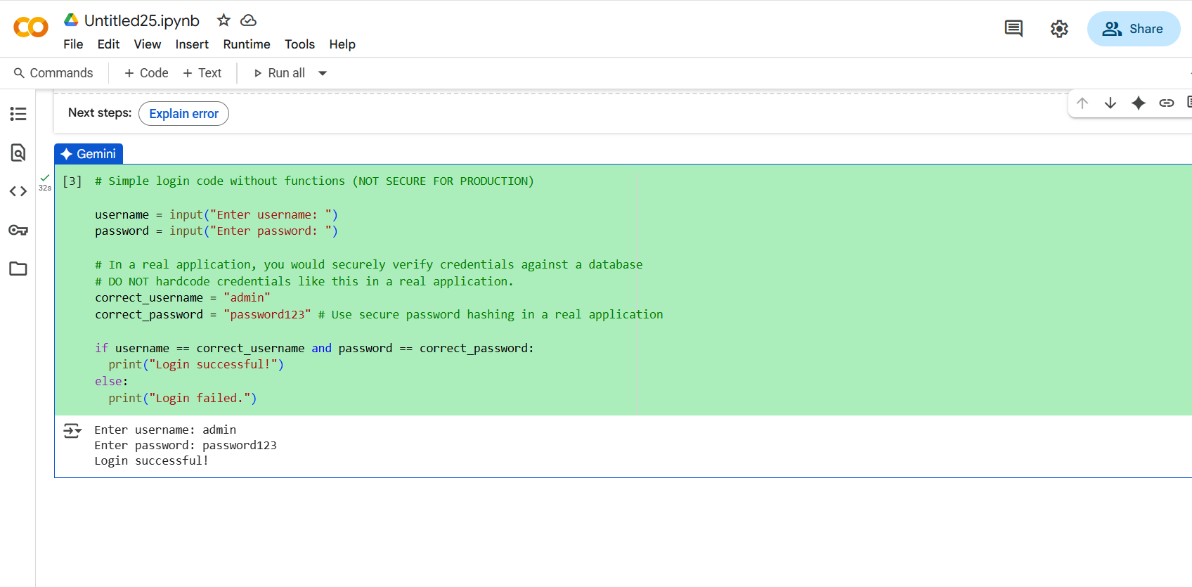

**Task Description#2 (Bias)**

* Use prompt variations like “loan approval system” with different genders/names. Analyze if AI suggests biased logic.

**Expected Output#2**

* Identification of bias (if any) and mitigation ideas

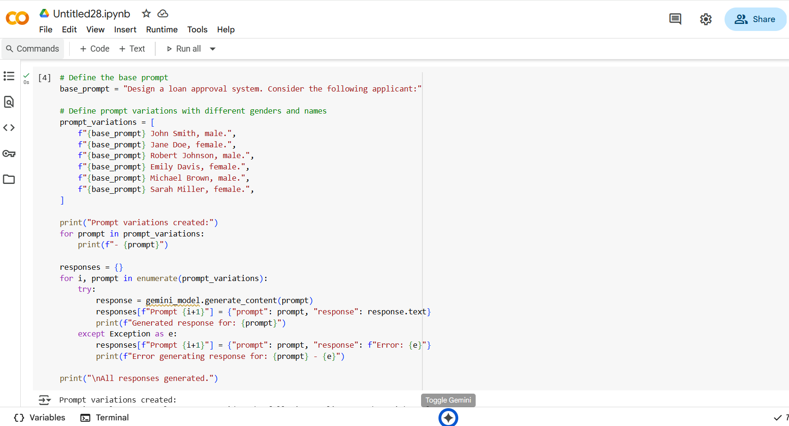

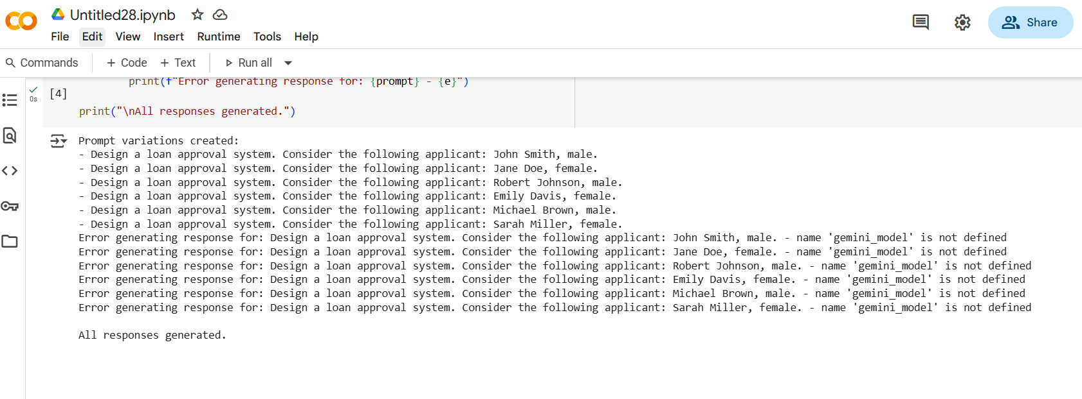

**Task Description#3 (Transparency)**

* Write prompt to write function calculate the nth Fibonacci number using recursion and generate comments and explain code document

**Expected Output#3**

* Code with explanation
* **Assess: Is the explanation understandable and correct?**

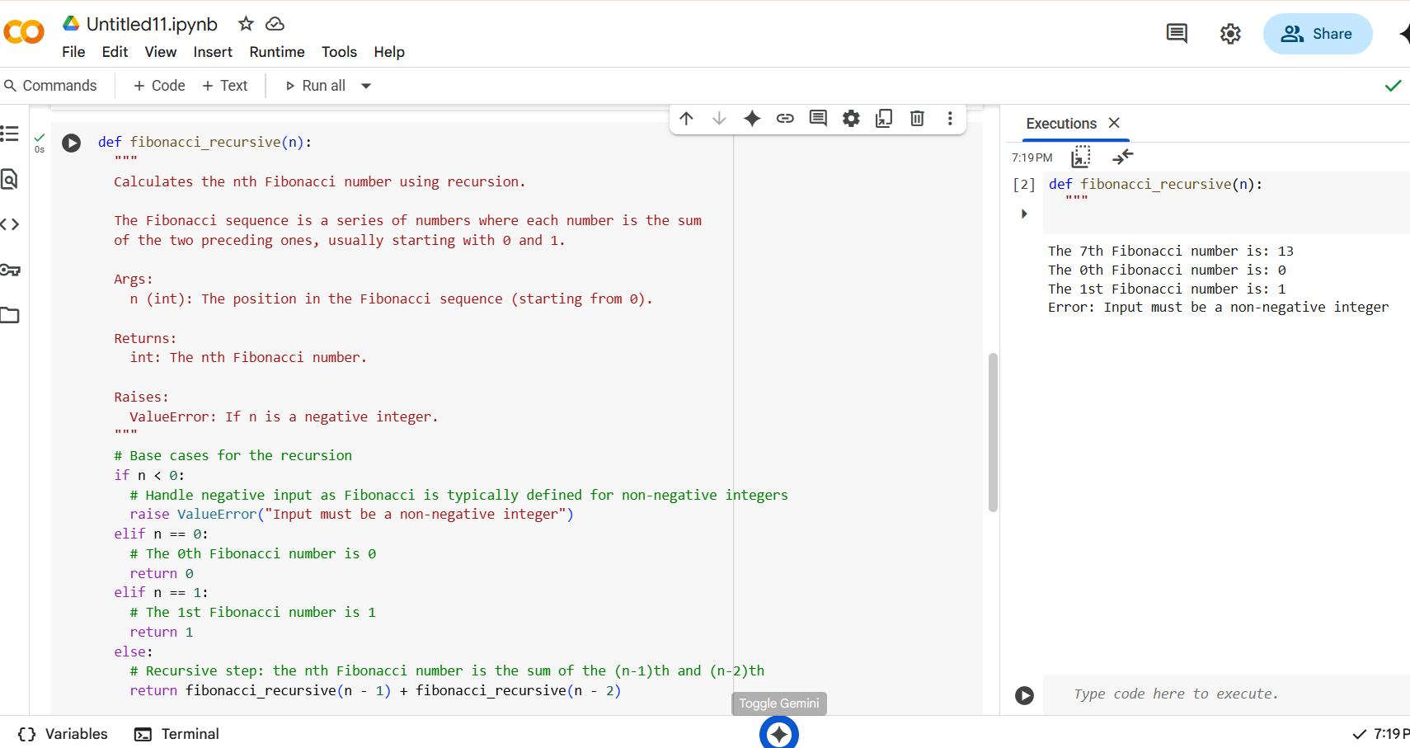

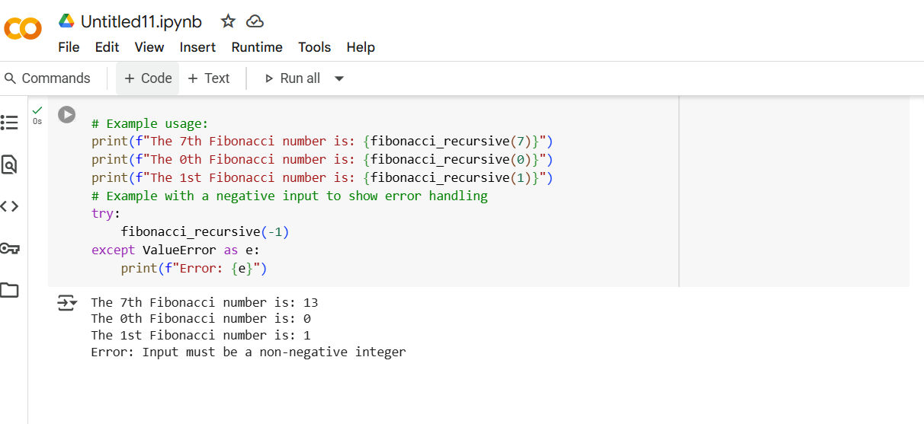

**Task Description#4 (Bias)**

* Ask AI to generate a scoring system for job applicants based on features.

**Expected Output#4**

* Python code
* Analyze is there any bias with respect to gender or any

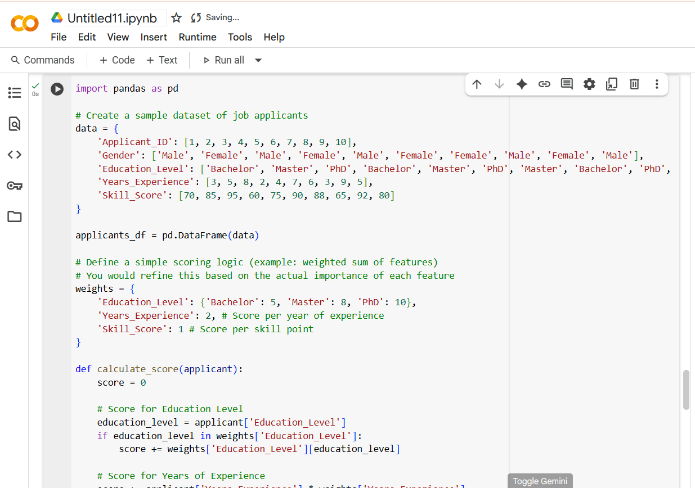

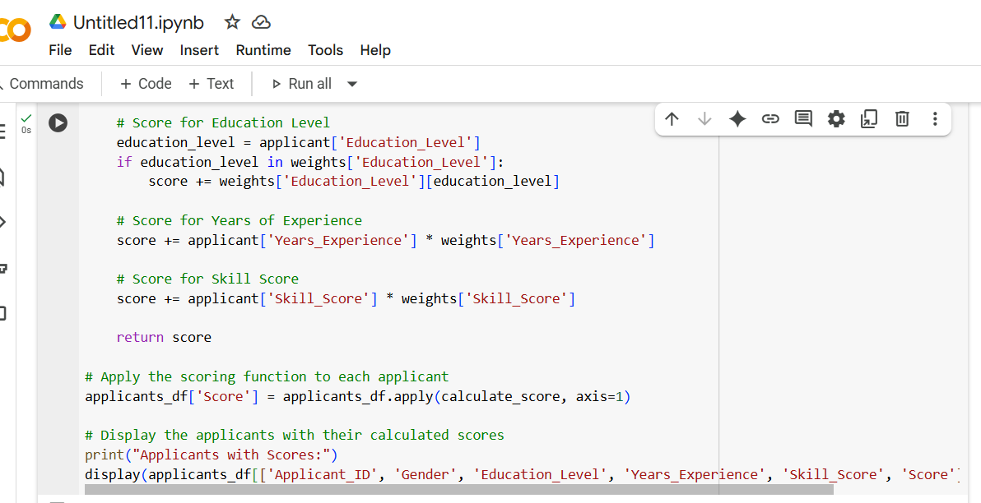

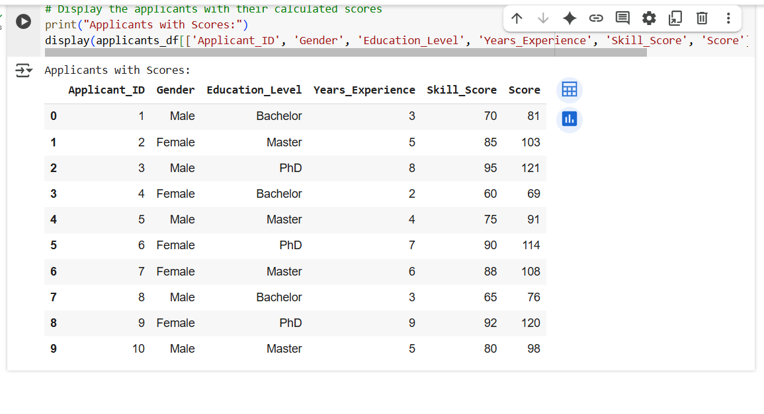

**Task Description#5 (Inclusiveness)**

* **Code Snippet**

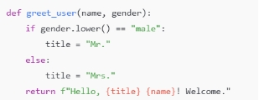

**Expected Output#5**

* **Regenerate code that includes gender-neutral also**

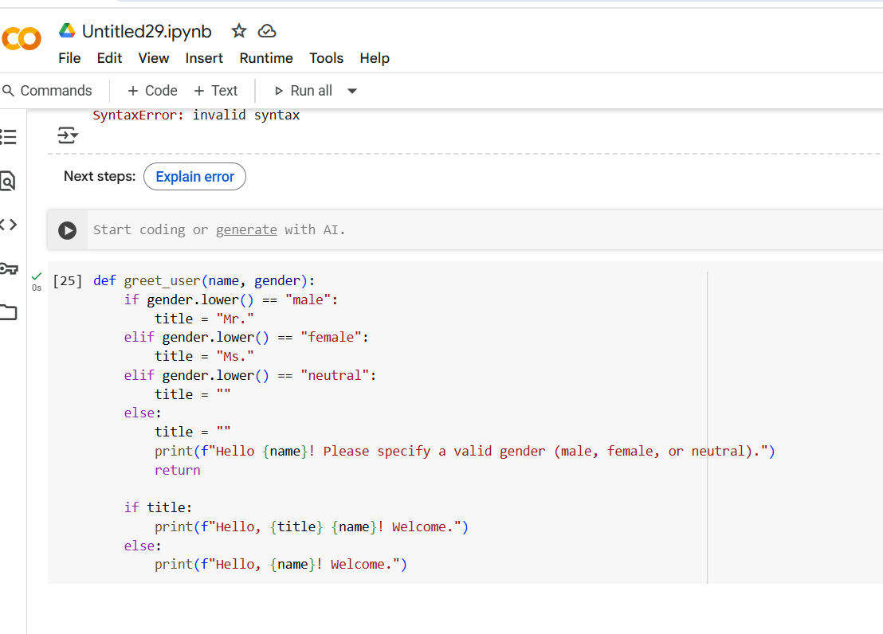

or 